PENISTONE THEATRE GROUP PRESENTS

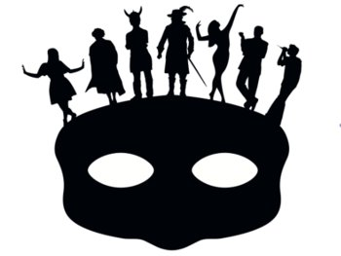
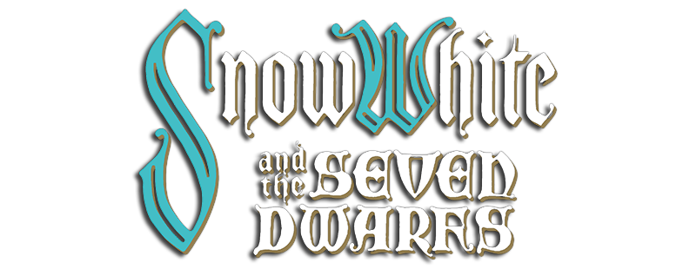

Dear Scouts & Parents

We have organised a group trip to see the Penistone Theatre Group performance of SNOW WHITE & THE SEVEN DWARFS on Friday 2nd February 2018. The trip is open to all Cubs, Scouts, Explorers and even Parents & Siblings. The cost is £6.00 per person.

CLOSING DATE 31ST OCTOBER 2017

If you would like to attend, please fill out the enclosed booking form and return along with monies via your child’s section leader. Cheques payable to “Penistone Scouts Camp Account”. We will send details or arrival times nearer the time.

If you have any queries please do not hesitate to contact me.

Yours in Scouting
Bruce
Penistone Scout Group
bruce68@hotmail.co.uk
Tel: 01226 762081
Mobile: 07921 766357

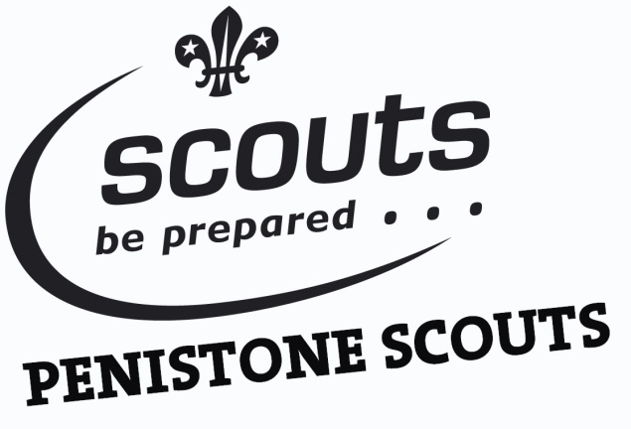

SNOW WHITE & THE SEVEN DWARFS
Booking Form
Description | Cost | QTY | TOTAL
PANTO TICKET | £6.00
 |  | TOTAL
Child’s Name: __________________________________________

Section: Alegre / Bella Vista / Raptors / Wibbles / Viernes / Enigma / Scorpion
(Please Circle)

SIGNED __________________________________ DATE______________

Address: _____________________________________________________________________
________________________________________________________Post Code:____________
Home number:__________________ Mobile number:______________________
Email:______________________________
All cheques made payable to “Penistone Scouts Camp Account”

Please return the booking form and monies to your son /daughters Section Leader

