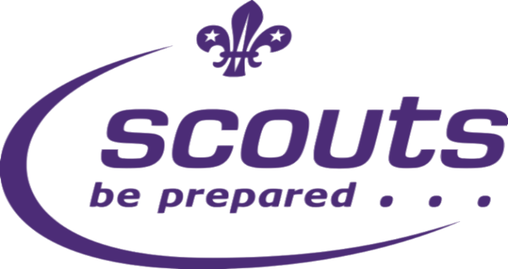
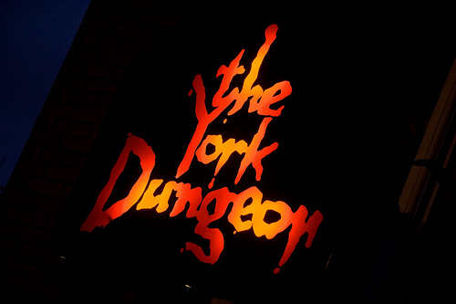

Enigma Troop

Enigma Scouts Christmas Sleepover
2nd -3rd December 2017

Scouts & Parents

Congratulations on securing your place on this year’s Christmas Sleepover based at Penistone Scouts Activity Centre, Wentworth Road, Pensitone. Any outstanding balances need to be cleared this week. If you are unsure of how much if any money is owed please ask one of the leader team and they can check immediately for you. Please make any cheques payable to Penistone Scouts Camp Account. Check in will take place from 8:15am on Saturday the 2nd December ready for a prompt departure at 9am. Can they scouts ensure they are suitably dressed for the weather as we will be spending quite a bit of time outside on both the Saturday and Sunday. Uniform is not required however they must wear their neckers. Whilst no specialist kit is required for the sleepover, a day sack is essential to carry around their lunch in York on the Saturday. On this occasion due to us visiting York for the day mobile phones will be permitted. During the activities but they will be collected in once we return and locked away overnight and returned Sunday Morning. We aim to have had our Christmas dinner and conclude the sleepover at 2pm on the Sunday. If this changes I will text on the day, otherwise we will see you at 2pm

Yours in Scouting
Shauna, Mike, Damon

Enigma Troop
shauna@penistonescoutgroup.org.uk
Mobile: 077207839861

WEEKEND CAMPERS – KIT LIST
To be worn on arrival
Group Necker with Woggle
Luggage – (Contained in one large bag / rucsac)
Sleeping Bag (3 Season)
Blanket
Toiletries & Towel
Suitable and enough clothing for weather and length of trip (T-shirts, Jumper, waterproofs, warm top / hoody, underwear etc..)
Walking Boots or Shoes
Indoor footwear
Drinks Bottle
Plastic Bag for dirty washing
Teddy Bear*

*- OPTIONAL

PLEASE mark all belongings with your Childs NAME

