Enigma Troop
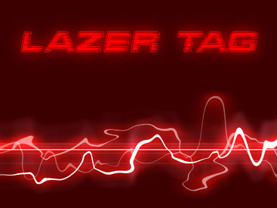

Laser Zone
Wednesday 13th December 2017

Scouts & Parents

On Wednesday 13th December we will be having an exciting and fun filled evening at Laser Zone, Huddersfield. This will replace our usual Monday evening meeting that week. The cost of the evening is £7.50, and this includes three games of Laser Tag. This can be paid either in advance or on the night but if you can let me know whether you will be attending as I need to book the exact number 7 days in advance. You will be responsible for making your own way their but there is plenty of spots to do Christmas shopping if you wish to wait parents. The start time will be 7pm and approximate finish of 8:30pm.

29 St John’s Road
Huddersfield
HD1 5DX
www.laserzone.cc

If you could aim to arrive by 18:45 and please wait outside of the venue for a leader to arrive as this will make checking in and paying much easier

Yours in Scouting
Shauna, Mike, Damon

Enigma Scouts
shauna.avon@sky.com
Mobile: 077207839861

