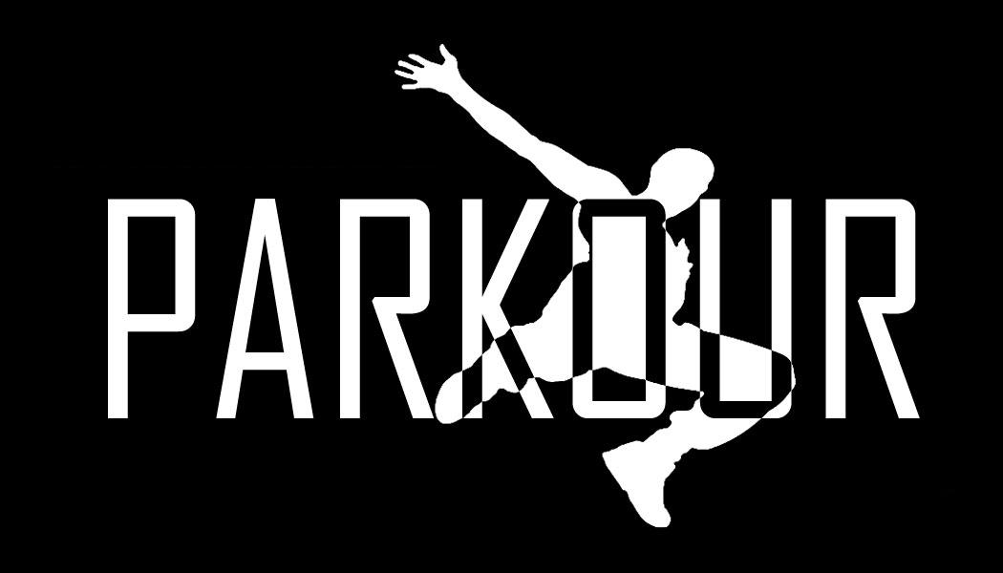
This Photo by Unknown Author is licensed under CC BY-SA

Parkour
Thursday 21st December 2017

Hi Cub Parents

Next month on Thursday 21st December we have managed to secure an exciting but energetic meeting of Parkour at Team Katalyst. This activity will be in lieu of a selection box for Christmas this year. Whilst there is no charge for this activity as Bella Vista Cubs are paying in full we still need to know in advance if your cub would like a place on this trip. Also if you book on and subsequently cancel/fail to attend the £5 full cost will become payable. You will need to make your own way to and from the venue and the address is:

Unit 1, The Summit
Mangham Road
Barbot Hall Industrial Estate
Rotherham
S61 4RJ
https://teamkatalyst.com

You will need to arrive at 18:15 and collection will be at 20:00 and there is either Parkgate nearby for a spot of last minute shopping or a basic café onsite if you wish to stay

Yours in Scouting
Mike, Shauna, Sam

Bella Vista Cubs
shauna.avon@sky.com
Mobile: 077207839861

