Enigma’s 1st Birthday Party
Monday 14th May 2018
18:00-21:00hrs

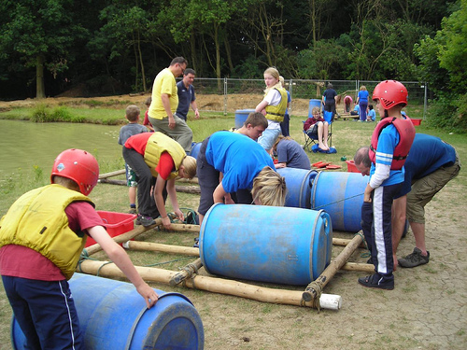
On the date shown above the leader team would like to invite your scout along to our 1st birthday celebration at Hesley Wood Scout Activity Centre, White Lane, Chapeltown, Sheffield, S35 2YH. We have planned an exciting evening of water-based team building activities complete with a BBQ, refreshments and Cake.
This Photo by Unknown Author is licensed under CC BY-NC-ND

We will be meeting just off the main car park next to reception at about 17:50 so we can make our way down to the lake to start at 6pm. Collection at the end of the evening will be from the long field. If you look on the map and head towards the lake you will hear us I’m sure. Once at the lake we will divide into three groups and begin the evening’s fun and games. These include an hours Raft Building, one-hour Canoeing and the final hour of wide games and cooking burgers on the gas BBQ, any dietary requirements need to be disclosed at the time of booking to enable us to cater for them.
This Photo by Unknown Author is licensed under CC BY-ND

The cost of this evening is being subsidised by Enigma Scouts so will be just £5 to attend. However, if you book on and then fail to attend then the full price of up to £15 will become payable. Please make cheques payable to ‘Enigma Scouts’. To book on please return the below slip with full payment as soon as possible.

……………………………………………………………………………………………………………………………………………….

I would like to book a place for my scout……………………………………………..to attend Enigma’s 1st Birthday Evening and give consent to participate in both raft building and canoeing. I confirm my scout is confident around water and can swim 50m clothed.

Signed:…………………………………………….
Dated:……………………………………………...

